Data Visualization – CSE3020

Lab 2 – Demonstrating Lattice Plots in R

Name: Ayush Sharma

Reg. No: 15BCE1335

Faculty: Dr. Priyadarshini J.

1. Constructing the various visual analytics charts using Lattice Plots in R.

Code:

hsb2 <- read.table('http://www.ats.ucla.edu/stat/r/modules/hsb2.csv', header=T, sep=",")

attach(hsb2)

library(lattice) #defining ses.f to be a factor variable

hsb2$ses.f = factor(hsb2$ses, labels=c("low", "middle", "high"))

#histograms

histogram(~write, hsb2)

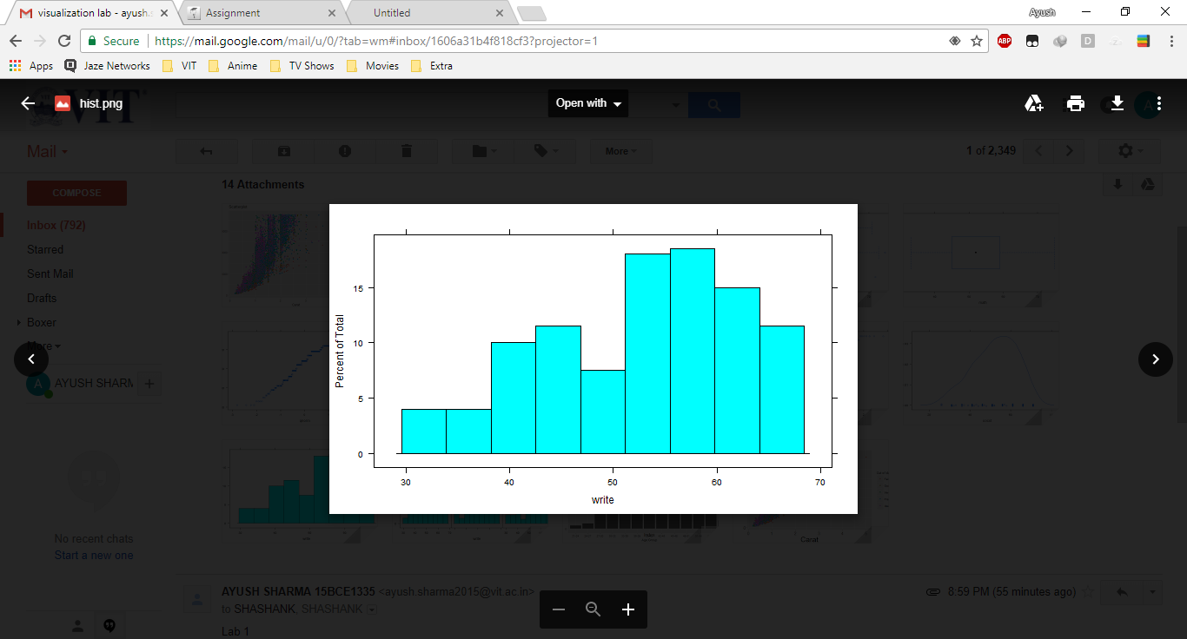

#conditional plot

histogram(~write | ses.f, hsb2)

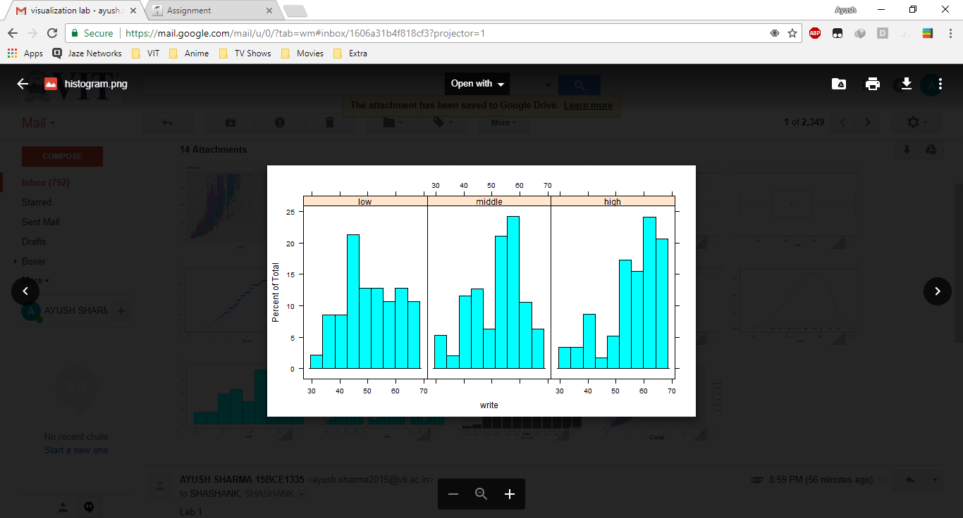

#Density plots

densityplot(~socst, hsb2)

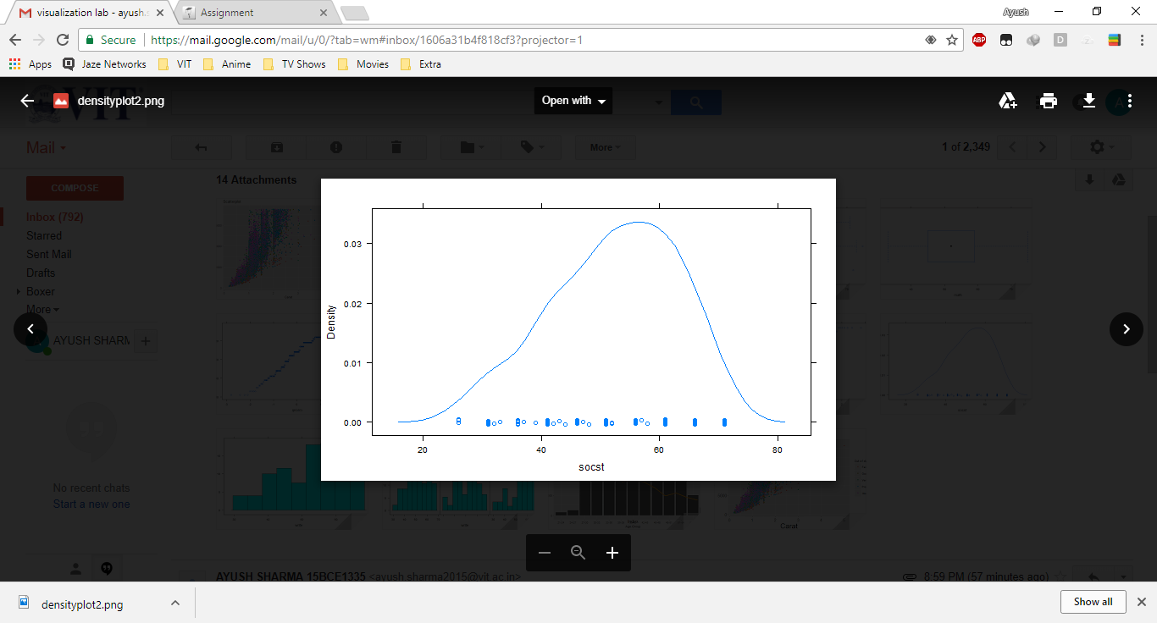

#conditional plot

densityplot(~socst | ses.f, hsb2)

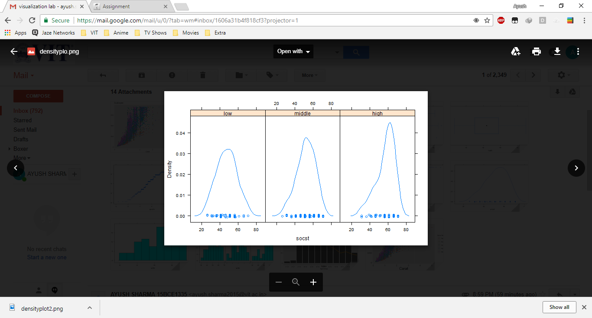

#Quantile-quantile plots

qqmath(~write, hsb2)

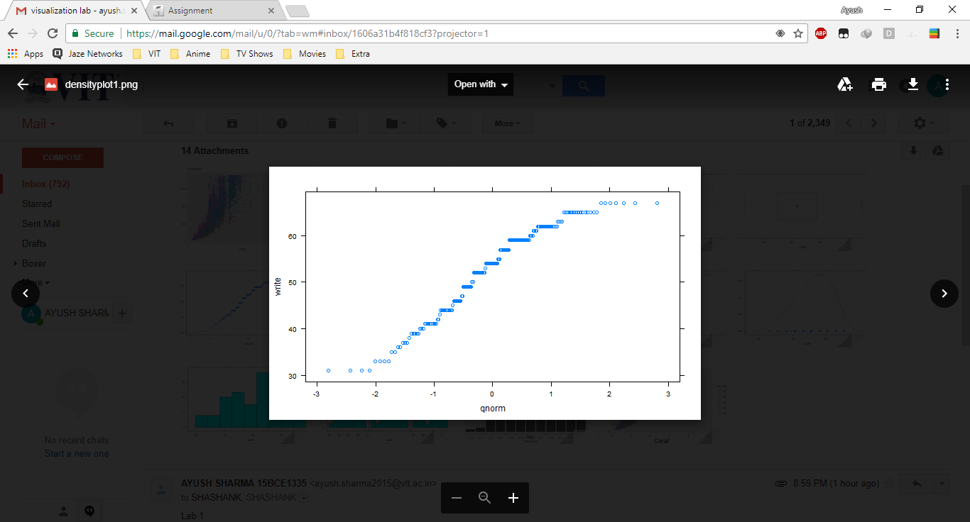

#conditional plot

qqmath(~write | ses.f, hsb2)

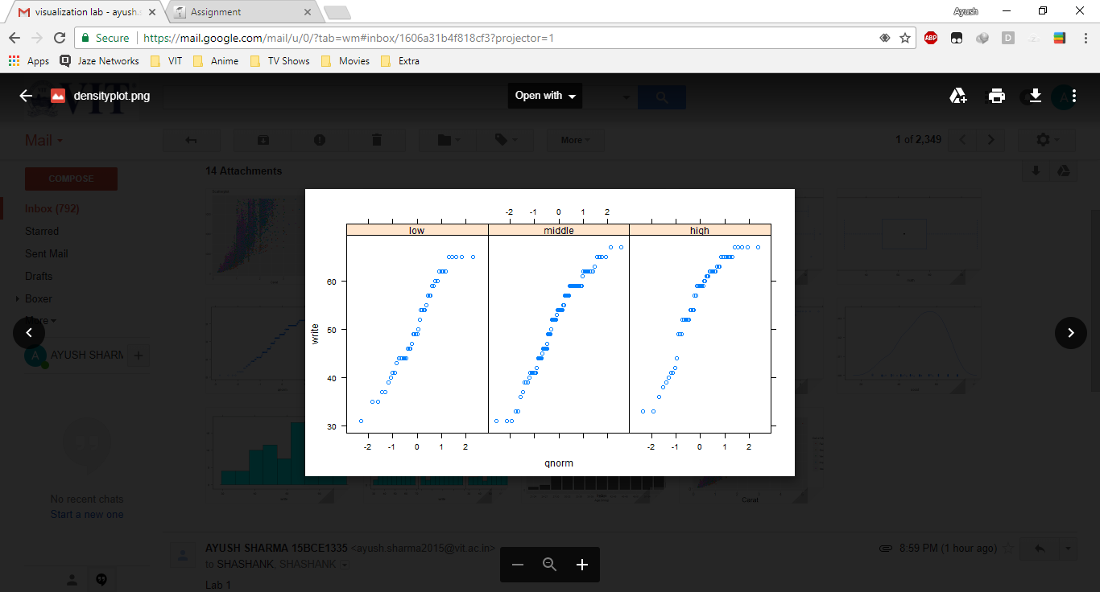

#Box and whiskers plots

bwplot(~math, hsb2)

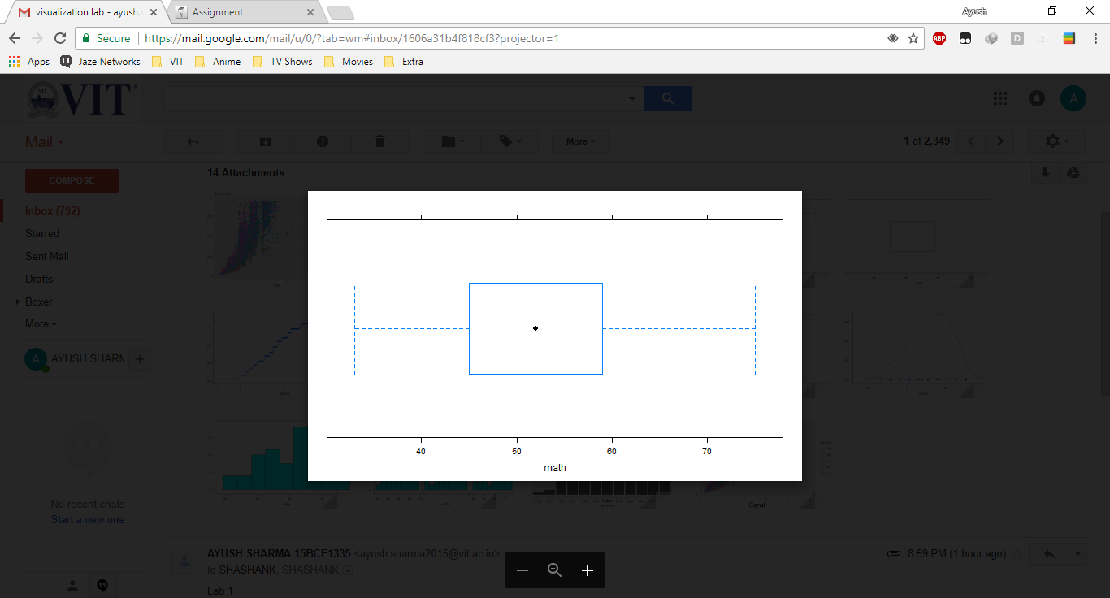

#conditional plot

bwplot(ses.f~math, hsb2)

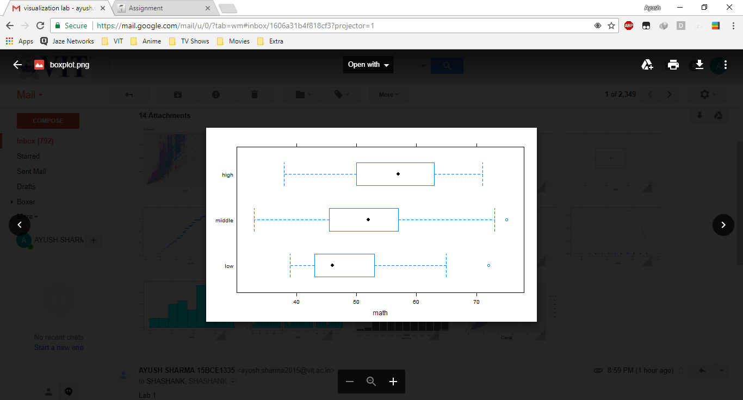

#Scatter plots

xyplot(write~math, hsb2)

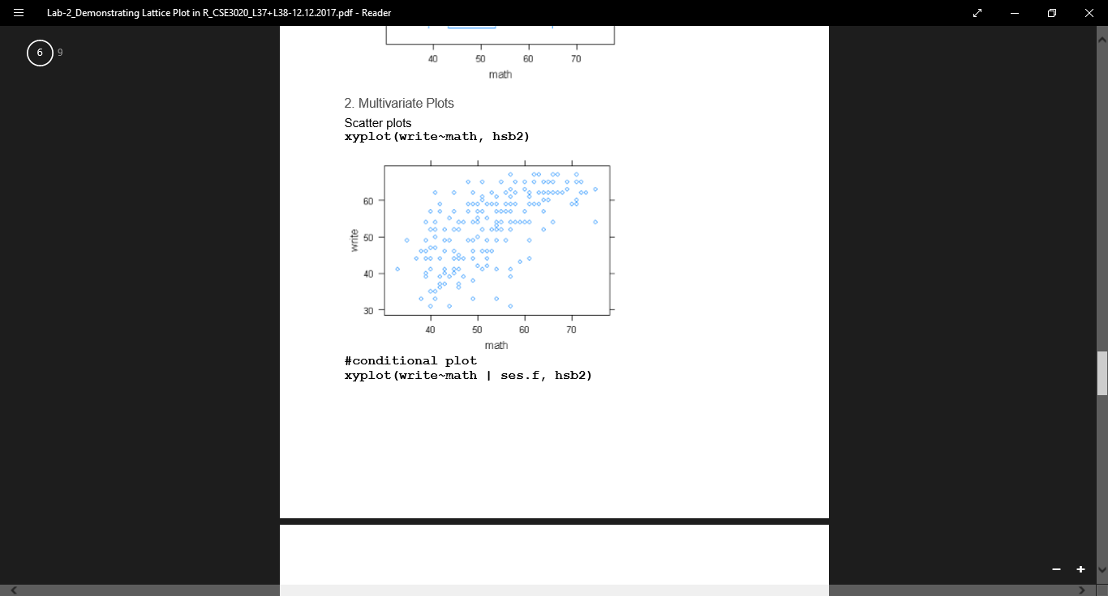

#conditional plot

xyplot(write~math | ses.f, hsb2)

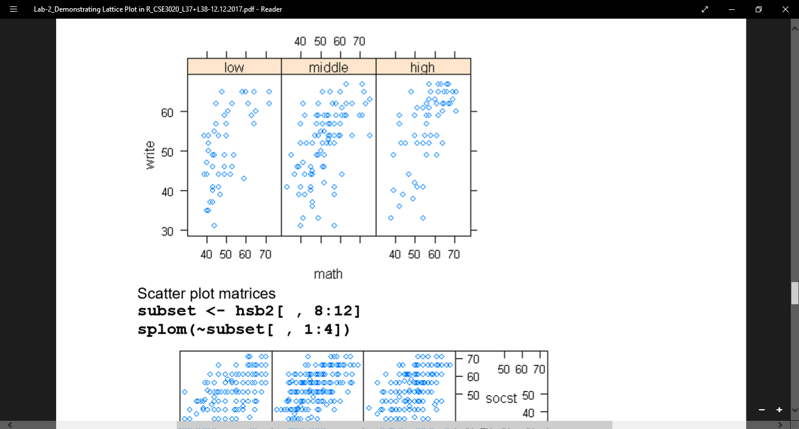

1. Some more Plots using diamond dataset

Code:  
ggplot(diamonds) + geom_point(aes(x=carat, y=price, color=cut)) + geom_smooth(aes(x=carat, y=price, color=cut)) # Same as above but specifying the aesthetics inside the geoms.

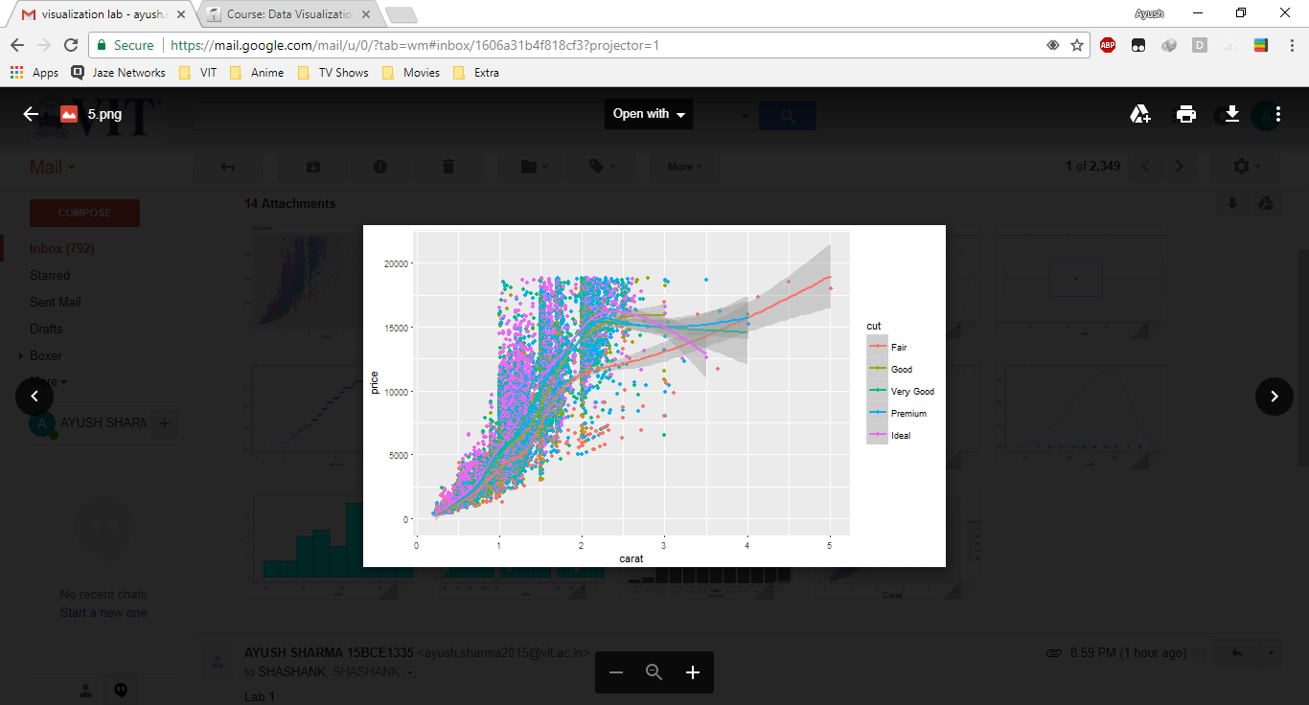

library(ggplot2) gg <- ggplot(diamonds, aes(x=carat, y=price, color=cut)) + geom_point() + labs(title="Scatterplot", x="Carat", y="Price") # add axis lables and plot title. print(gg)

